**Designing The ManagerOptionsFrame**

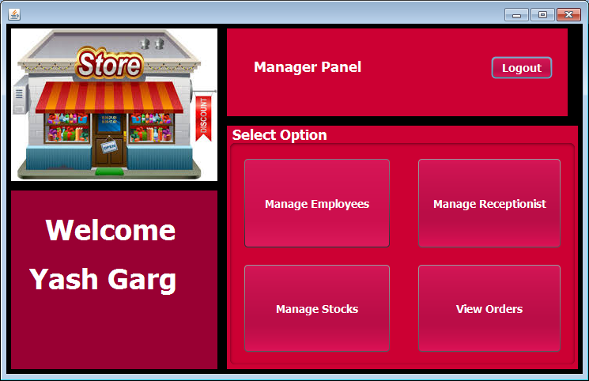

**STEPS TO BE DONE IN** **ManagerOptionsFrame**

In the **ManagerOptionsFrame** we need to do following steps:

1. Display **username** on the top left

2. Allow the user to **logout**

3. Provide the following options:

**Manage Employees**

**Manage Receptionist**

**Manage Stocks**

**View Orders**

**Displaying The Username**

We can recall that we saved the **username** and **usertype** in the static fields of the class **UserProfile** . So in the constructor of **ManagerOptionsFrame** we will call the **getUsername( )** method of the class **UserProfile** to get the username and display it in the Label.

**Allowing The User To Logout**

To allow the user to logout , we will provide a button at the top right corner with the following functionality:

**a. When the user will click on the Button, the user will be logged out i.e. we will dispose the current frame and open the LoginFrame.**

**Handling The Options**

The next task is to allow the user to click on the buttons amongst **Manage Employees,Manage Receptionist, Manage Stocks and View Orders**

To do this we need to handle the Buttons in the following way:

1. **When the button will be clicked actionPerformed of that specific button will be handled first we create the object of next frame and setVisible propert true and dispose the current frame**